

Student Name……………………………………

MATHEMATICAL METHODS (CAS) UNITS 3 & 4

TRIAL EXAMINATION 1

2015

Reading Time: 15 minutes
Writing time: 1 hour

Instructions to students
This exam consists of 10 questions.
All questions should be answered in the spaces provided.
There is a total of 40 marks available.
The marks allocated to each of the questions are indicated throughout.
Students may not bring any calculators or notes into the exam.
Where an exact answer is required a decimal approximation will not be accepted.
Where more than one mark is allocated to a question, appropriate working must be shown.
Diagrams in this trial exam are not drawn to scale.
A formula sheet can be found on page 12 of this exam.

This paper has been prepared independently of the Victorian Curriculum and Assessment Authority to provide additional exam preparation for students. Although references have been reproduced with permission of the Victorian Curriculum and Assessment Authority, the publication is in no way connected with or endorsed by the Victorian Curriculum and Assessment Authority.

© THE HEFFERNAN GROUP 2015
This Trial Exam is licensed on a non transferable basis to the purchasing school. It may be copied by the school which has purchased it. This license does not permit distribution or copying of this Trial Exam by any other party.
Question 1 (5 marks)

- Differentiate 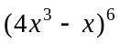 with respect to x. 2 marks

- If 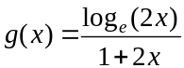, find 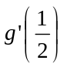. 3 marks

Question 2 (2 marks)

Find 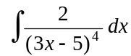

Question 3 (2 marks)

Solve 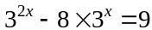 for x.

Question 4 (2 marks)

Solve .

Question 5 (5 marks)

Let 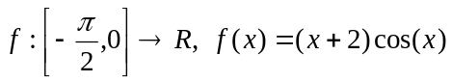.
The graph of 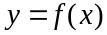 is shown below.

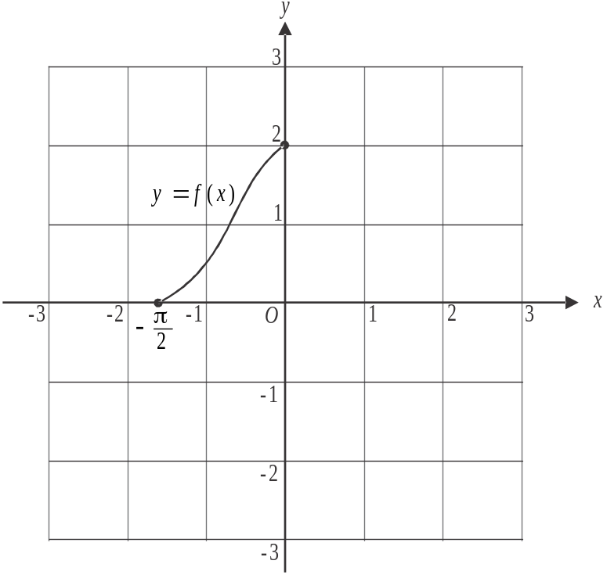

- Find the gradient of the graph of at the point where 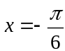. 3 marks

- Sketch the graph of the inverse function 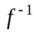 on the set of axes above.
Indicate clearly the coordinates of the endpoints of the graph. 2 marks
Question 6 (3 marks)

The transformation 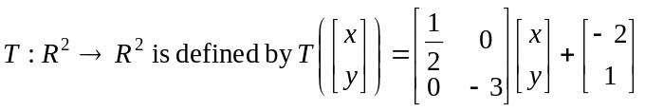.

Under this transformation the image of the curve 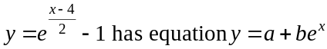.
Find the values of a and b.

Question 7 (5 marks)

Consider the functions 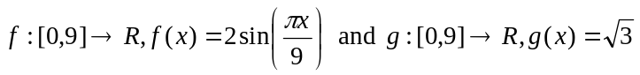.

- Find the coordinates of the points of intersection of the graphs of 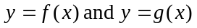. 2 marks

- Find the area enclosed by the graphs of 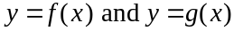. 3 marks

Question 8 (4 marks)

A continuous random variable X has a probability density function given by

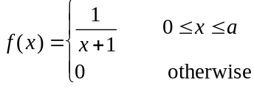

where a is a positive constant.

- Find the value of a. 2 marks

- The median of X is m where 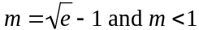.
Find 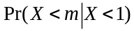. 2 marks

Question 9 (6 marks)

Geoff owns a lawn mowing business. If there is no rain during a week then the probability that he completes all his jobs is 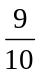, but if there is rain, then the probability that he completes all his jobs is .
The probability that there is rain one week is assumed to be independent of there being rain during any other week.

- Find the probability that during the last fortnight, when there was no rain, Geoff completed all of his jobs in one week but not the other. 2 marks

During winter, the probability of there being rain during a week is .

- i. Find the probability that during the first week of winter, Geoff completed all of his jobs. 2 marks

  - Find the probability that during a different week in winter there was rain, given that Geoff didn’t complete all of his jobs that week. 2 marks

Question 10 (6 marks)

The graph of 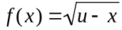 is shown below where u is a positive real number.

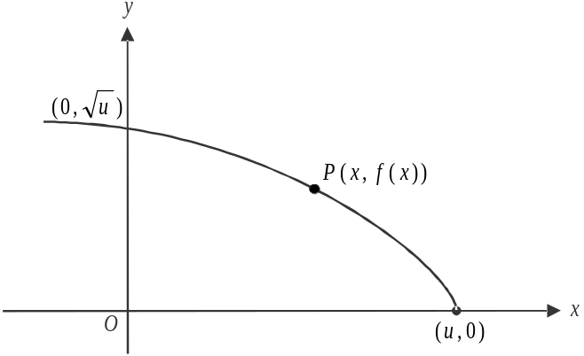

The point 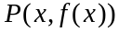 lies on the graph.

- When the gradient of the tangent to the graph at P equals 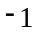, find

- the y-coordinate of P. 2 marks

- the horizontal distance between P and the x-intercept of this tangent. 1 mark

- The point 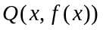 also lies on the graph of f.

The rectangle OMQN is shaded in the diagram below.

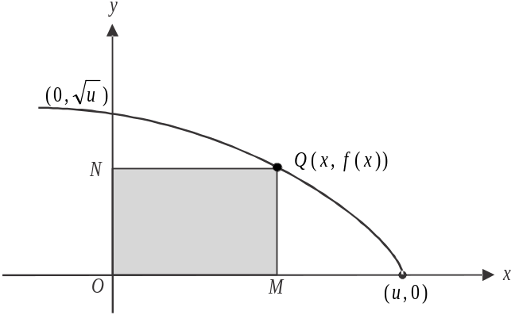

Find the maximum area of this rectangle. Express your answer in terms of u. 3 marks

Mathematical Methods (CAS) Formulas

Mensuration

area of a trapezium: 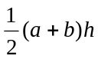 volume of a pyramid: 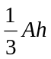
curved surface area of a cylinder: 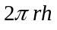 volume of a sphere: 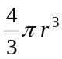
volume of a cylinder: 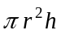 area of a triangle: 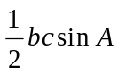
volume of a cone: 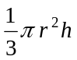

Calculus
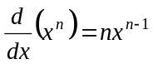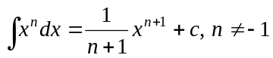
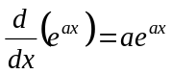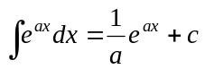
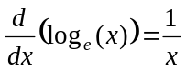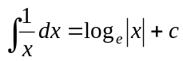
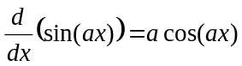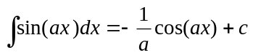
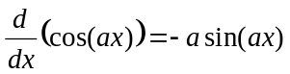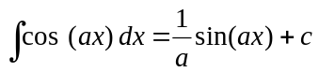
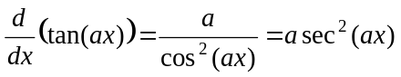
product rule: 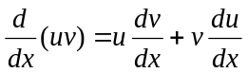 quotient rule: 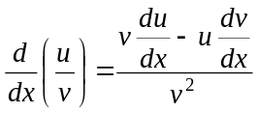
chain rule: 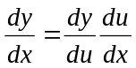 approximation: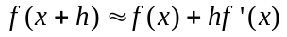

Probability
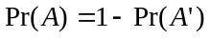
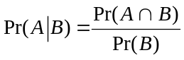 transition matrices: 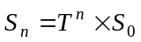
mean: 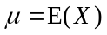 variance:

probability distribution |  | mean | variance
discrete | 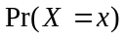=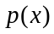 | 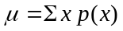 | 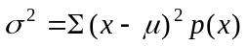
continuous | 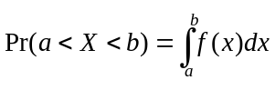 | 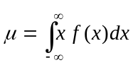 | 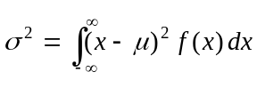
Mathematics Formula Sheets reproduced by permission; © VCAA 2014. The VCAA does not endorse or make any warranties regarding this study resource. Current and past VCAA VCE® exams and related content can be accessed directly at www.vcaa.vic.edu.au

